Report on the Validation
of the Requirements
in the
AMS(R)S SARPs for Iridium

Revision 2.0
8 March 2007

Date &  Version | Change
09/01/06 v0.1 | Draft document prepared by M. Meza
10/05/06  v0.2 | Revised Draft prepared by M. Meza
10/26/06  v0.3 | Revised Draft with IRD working group input by M. Meza
12/12/06  v0.4 | Revised to add auto-dialer set up description, section 3.0, and fault detection and annunciation diagram per WG input
1/05/2007  v.0.5 | Revised draft based on updated and finalized SARP language and additional Iridium data. (K. O’Keefe)
v.0.6 | Draft revision resulting from WG-07 meeting in Tempe, AZ.
v.1.0 | Revisions following Tempe meeting and in preparation for WG-08.
V1.1 | Revisions to include capacity study, 24 bit ICAO address handling and other issues identified during WG-07
v.2.0 | Revised Draft for meeting IRD WG-8

Introduction

Objective
The objective of this technical report is to demonstrate that the Iridium Satellite Aeronautical Mobile Satellite (Route) Service (AMS(R)S) can meet or exceed the technical intent of the AMS(R)S Standards and Recommended Practices (SARPs).
This report is to be considered in conjunction with the SARPs as contained in Annex 10, Volume III, Part I, Chapter 4.

Scope
This report directly compares the expected performance of the Iridium Satellite Network’s AMS(R)S with the technical and performance requirements outlined in the AMS(R)S SARPs.

Validation Methodologies
Inspection
IA Inspection using common knowledge
IB Inspection through use of prior analysis/documents
MN Monitoring and/or measurement
MD Manufacturer’s data
Test
IT Integration test
UT Unit Test
FT Flight Test
Simulation, Comparison and Analysis
A Analysis
S Simulation
C Comparison with similar device and/or system
No validation required (may include editorial inspection), NVR

Comparison of AMS(R)S SARPs and expected Iridium performance

This section contains information provided by Iridium Satellite LLC regarding Iridium satellite network’s conformity with AMS(R)S SARPs. Table 2-3 tabulates the AMS(R)S SARPs requirements and the associated Iridium-specific performance parameters.
Throughout this document the Satellite Network Operation Provider may be referred to as Iridium, Iridium Satellite, or ISLLC. Refer to the list of definitions in Part 2 of the Technical and Implementation Manual for a description of a Satellite Network Operation Provider.
Throughout this document the Satellite Communications Services Provider may be referred to as safety services provider or safety services SP. Refer to the list of definitions in Part 2 of the Technical and Implementation Manual, for a description of a Satellite Communications Services Provider.
Refer to the list of definitions in Part 2 of the Technical and Implementation Manual, for a description of a Terrestrial Network Services Provider and other terms related to provision of Iridium AMS(R)S..
Example of a validation report

Original Requirement
The AES equipment shall operate properly in an interference environment causing a cumulative relative change in its receiver noise temperature (ΔT/T) of 25 per cent.
[AMS(R)S SARPs, 4.3.3.1]

Requirement Validation:
Validation Methods = A, Reference Annex B, WP-599

Validation Details:
A 25% increase in receiver noise temperature is equivalent to a 1.0 dB link margin degradation. This additional degradation due to interference is accounted for in the Iridium link budget. The service links are designed to provide a 15 dB margin.

GENERAL

2.1.1 General
Any mobile satellite system intended to provide AMS(R)S shall confirm to the requirements of this chapter. [AMS(R)S SARPs, 4.2.1]

2.1.1.1
Original Requirement(s):
An AMS(R)S system shall support packet data service, or voice service, or both. [AMS(R)S SARPs, 4.2.1.1]

Requirement Validation:
Validation Methods = will be detailed in each section of this report

Validation Details:
Iridium currently provides voice and data services in the aviation sector. Iridium data is format neutral and can support both character and bit-oriented data traffic. Voice service is in use today on fixed and rotary wing aircraft.

It is expected that the Iridium satellite network can support both voice and packet data service and based on information provided below, will maintain availability .999897.

RF CHARACTERISTICS

2.2.1 Frequency Bands
Note – ITU Radio Regulations permit systems providing mobile-satellite service to use the same spectrum as AMS(R)S without requiring such systems to offer safety services. This situation has the potential to reduce the spectrum available for AMS(R)S. It is critical that States consider this issue in frequency planning an in the establishment of national or regional spectrum requirements.

2.2.1.1 Frequency Bands
Original Requirement(s):
When providing AMS(R)S communications, an AMS(R)S system shall operate only in frequency bands which are appropriately allocated to AMS(R)S and protected by the ITU Radio Regulations.
[AMS(R)S SARPs, 4.3.1.1]

Requirement Validation:
Validation Methods = A

Validation Details:
The spectrum used for the Iridium satellite service is regulated according to Nos. 5.359, 5.364, 5.365, 5.366, and 5.367 of the Radio Regulations. No. 5.364 specifies sharing conditions and coordination requirements for MSS (Iridium) earth stations in the Earth-to-space direction. No. 5.365 requires coordination for space-to-Earth transmissions. The required coordinations have been carried out and the Iridium System service link spectrum was notified to the ITU-BR in 1998. An indication of this may be found in the ITU-BR International Frequency List (IFL), and thereby, the frequency assignments in the Notification are entitled to protection.

The system was brought into use in the mid 1990’s. Coordination under No. 5.366 and 5.367 regarding use of satellite facilities on airplanes and use of the AMS(R)S on a primary allocation basis, respectively, have been carried out under the provisions of these regulations (No. 9.21).

Finally, coordination with Fixed services in the countries indicated in 5.359 has also been carried out. This regulation encourages the indicated countries to not authorize additional fixed stations in the band.

2.2.2 Emissions

      - Interference to Other Systems

Original Requirement(s):
The total emissions of the AES necessary to meet designed system performance shall be controlled to avoid harmful interference to other systems necessary to support safety and regularity of air navigation, installed on the same or other aircraft.

Note 1.— Harmful interference can result from radiated and/or conducted emissions that include harmonics, discrete spurious, intermodulation product and noise emissions, and are not necessarily limited to the "transmitter on” state.

Note 2.— Protection requirements for GNSS are contained in Annex 10, Volume I.
[AMS(R)S SARPs, 4.3.2.1]

2.2.2.2 Interference to AMS(R)S Equipment on Other Aircraft

2.2.2.2.1 Interference to AMS(R)S equipment on other aircraft
Original Requirement
Emissions from an AMS(R)S system AES shall not cause harmful interference to an AES providing AMS(R)S on a different aircraft. [AMS(R)S SARPs, 4.3.2.2.1]

Note.— One method of complying with 4.3.2.2.1 is by limiting emissions in the operating band of other AMS(R)S equipment to a level consistent with the intersystem interference requirements such as contained in RTCA document DO-215. RTCA and EUROCAE may establish new performance standards for future AMS(R)S which may describe methods of compliance with this requirement.

Requirement Validation:
Validation Methods = A; Reference Annex B, WP-599

Validation Details:
The Iridium SDU installed as the active RF component of the AES are designed to meet the emission requirements of RTCA DO-262. This together with a predefined AMS(R)S antenna to GNSS antenna isolation should ensure that AMS(R)S equipment can be operated simultaneously and independently from other communication and navigation equipment installed on the same or other aircraft. [AMS(R)S SARPs, 4.3.2 and sub-paragraphs]
The Iridium SDU have been designed and tested to insure compliance with the emission limits set out in ITU-R Recommendation M.1343, “Essential technical requirements of mobile earth stations for global non-geostationary mobile-satellite service systems in the bands 1-3 GHz”, as well as national/regional type-approval specifications such as FCC Part 2 and Part 25 and ETSI EN301 441 specifications. FCC and ETSI measurements of standard Iridium SDU have shown that the Iridium SDU meets the specified emission limits.
Compliance of Iridium AES equipment emissions to existing protection requirements for various other onboard radio transceivers is summarized by two tables: Table 1 in Attachment 1 of WGA/14 WP-599 (see Annex B to this document) and Table 2-1 below. Table 1 of WP-599 provides a summary of the Iridium AES emissions MOPS relative to various onboard aviation CNS (communications, navigation and surveillance) equipment, as well as on other radio services (e.g., the Radio Astronomy Service). Since WP-599 was written, the RTCA released DO-294A, which modified the methodology for analyzing interference from Transmitting Personal Electronic Devices (T-PED) to some of the radio services listed in Table 1 of WP-599. Therefore, Table 2-1 below has been provided to show how the MOPS for Iridium AES emissions comply with the methodology of Table 6-1 in DO-294A. It should be noted that Table 6-1 does not specify output emissions levels for transmitting devices; instead it specifies an aggregate input interference level from all possible devices and thus serves as an analytical tool for evaluating possible interference scenarios. Actual emissions limits for Iridium AES terminals are specified in DO-262, under which Iridium terminals are currently compliant. For further details on the derivation of values in Table 2-1, please refer to DO-294A.

Table 2-1: Summary of Iridium AES Emissions DO-294A Conformance
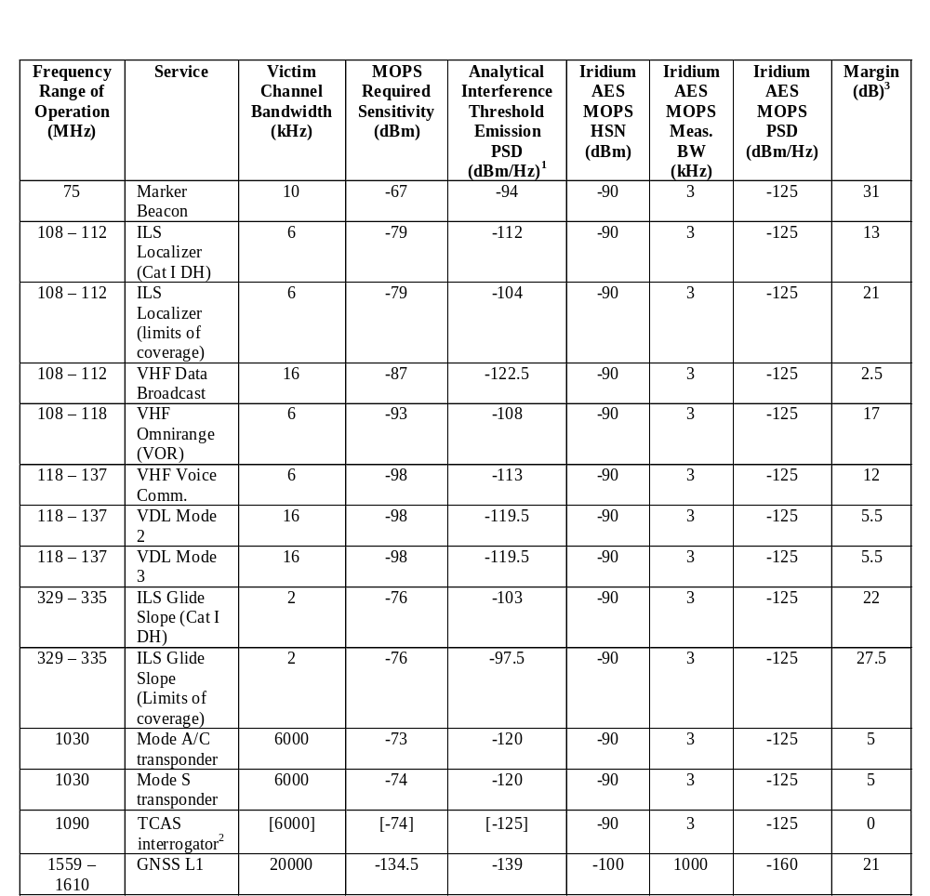

Notes:
- The Analytical Interference Threshold Emission PSD is derived from the RTCA document DO-294A, Table 6-1, “Analytical Aggregate T-PED Interference Threshold PSD” column. Since the PSD values in that column represent the aggregate interference level from all possible interferers at the input to the victim receiver, those PSD values must be adjusted to represent the emission PSD from the single interference source (in this case, Iridium AES). The adjusted value is found from Equation 6.1 in DO-294A as:
PSD_{T} = PSD_{I} + L_{P} – K_{ME},
where PSD_{T} is the transmitted emission power spectral density for the Iridium AES, PSD_{I} is the input aggregate interference threshold power spectral density from DO-294A, Table 6-1, L_{P} is the propagation loss between the Iridium AES antenna and victim receiver (which equals 52 dB, per DO-294A, table 5-4) and K_{ME} is the multiple equipment, aggregate interference factor (which equal 10 dB, per DO-294A, pg. 6.D-4).

- The values for this service are in brackets in DO-294, Table 6-1.

- Margin values in the last column are conservative estimates which make assumptions about path loss, multiple equipment factors and actual equipment implementation. It should also be noted that the actual Iridium emissions typically perform better than the levels defined in the MOPS.

2.2.3 Susceptibility

2.2.3.1 Susceptibility
Original Requirement(s):
The AES equipment shall operate properly in an interference environment causing a cumulative relative change in its receiver noise temperature (ΔT/T) of 25 per cent.
[AMS(R)S SARPs, 4.3.3.1]

Requirement Validation:
Validation Methods = A, Reference Annex B, WP-599

Validation Details:
A 25% increase in receiver noise temperature is equivalent to a 1.0 dB link margin degradation. This additional degradation due to interference is accounted for in the Iridium link budget. The service links are designed to provide a 15 dB margin.

PRIORITY AND PREEMPTIVE ACCESS

2.3.1 Priority and Preemptive Access
Original Requirement(s):
Every aircraft earth station and ground earth station shall be designed to ensure that messages transmitted in accordance with Annex 10, Volume II, 5.1.8, including their order of priority, are not delayed by the transmission and/or reception of other types of messages. If necessary, as a means to comply with the above requirement, message types not defined in Annex 10, Volume II, 5.1.8 shall be terminated even without warning, to allow Annex 10, Volume II, 5.1.8 type messages to be transmitted and received.

Note.— See ITU Radio Regulations No. 5.357A.
[AMS(R)S SARPs, 4.4.1]

Requirement Validation:
Validation Methods = A, U_{T}, and I_{T}, Reference Annex C, WP-598

Validation Details:
It is expected that the aircraft and ground earth station shall adhere to Annex 10 for transmission of messages. This can be accomplished in a number of ways such as embedded priority within the messages or message header, separate channels for voice and data, and harmonization between the avionics and the ground equipment, such that the two components can exploit the fullest capabilities of the Iridium Network for voice and data services.
(optional text)
[The basis for Iridium AMS(R)S Priority, Precedence, and Pre-emption (PPP) is the set of mechanisms designed for, and already implemented in, the Iridium Satellite Network for signaling and system management purposes. The Iridium Satellite Network utilizes two resource management functions, Acquisition Class control and Priority Class control, to assure access to communication channels for priority users.
The acquisition process is one of several protocols completed between an ISU and the satellite constellation for each call set up regardless if the call is mobile originated (from aircraft) or mobile terminated (to aircraft). For mobile originated call, the ISU will start the acquisition process once the call is placed. For mobile terminated call, the ISU will start the acquisition process upon the reception of a RING, indicating an incoming call from the GES.
Each satellite beam broadcasts which Acquisition Classes are allowed to acquire satellite resource on that beam. Only ISUs with the proper Acquisition Class (AC) are allowed to start the acquisition process. Acquisition Class ranges from 0-15. Default non-safety Iridium terminals use an Acquisition Class in the range of 0-9. AMS(R)S safety traffic will be assigned Acquisition Class 14.
Acquisition Class is mainly use for satellite load shedding. In a satellite beam with heavy traffic load, certain Acquisition Classes (e.g., AC0-9) will be shut down to prohibit further traffic load on the satellite. To ensure AMS(R)S safety traffic will get through, Iridium will not shut down AC14 for satellite load shedding.
The Acquisition Class affects how calls initially gain access to the satellite constellation while Priority Class provides continued access for safety-related calls.
The Iridium Satellite Network allows for four levels of priority. Each satellite has priority queuing for both channel assignment of new calls and handoff order of in-progress calls. High priority calls, taking precedence, are queued before low priority calls.
The four Iridium priority levels are mapped to the four-level AMS(R)S priority structure as specified by Table 2-7 of RTCA DO-262.
Iridium Priority 3 (AMS(R)S #4, Distress, Urgency, highest priority);
Iridium Priority 2 (AMS(R)S #3, Direction finding, Flight Safety);
Iridium Priority 1 (AMS(R)S #2, Other Safety and Regularity of Flight);
Iridium Priority 0 (AMS(R)S #1, AMSS Non-Safety, lowest priority).

In case of extreme system resource shortage, on-going low priority calls will be pre-empted by the system to allow access for higher priority call.
While the Iridium Acquisition Class Control and Priority Class Control provide internal system controls for internal PPP management, the Iridium AMS(R)S AES manufacturers and AMS(R)S service providers will need to provide the input/output queuing for call/message priority function at the Iridium network interfaces. These capabilities are intrinsic to the protocol machines that interface Iridium AMS(R)S with its external users, and reside in the AMS(R)S AES and GES.
Currently both the Acquisition Class and Priority Class are encoded on a SIM card; hence the Acquisition Class and Priority Class are associated with a SIM card and an ISU that uses that SIM card. For AMS(R)S, the acquisition class and priority class will need to be associated with each AMS(R)S call (type) and will be controlled by the protocol software that sets up the call.]

2.3.2 Identification of Priority
Original Requirement(s):
All AMS(R)S data packets and all AMS(R)S voice calls shall be identified as to their associated priority.
[AMS(R)S SARPs, 4.4.2]

Requirement Validation:
Validation Methods = I_{A}

Validation Details:
It is expected that the Iridium Network aircraft and ground stations shall be capable of supporting identification of priority of messages. This can be accomplished in a number of ways such as embedded priority within the messages or message header. In this example the avionics and ground station are harmonized to enable this feature.

2.3.3 Voice Priority Over Data
Original Requirement(s):
Within the same message category, the Iridium AMS(R)S service shall provide voice communications priority over data communications.
[AMS(R)S SARPs, 4.4.3]

Requirement Validation:
Validation Methods = I_{A}

Validation Details:
The Iridium Network is expected to support prioritization of voice over data via the avionics (terminal equipment). The Iridium Satellite Network supports voice and data services simultaneously. In addition, SBD does not utilize the same channel resources required for voice service. It is recommended for SDUs supporting voice and data service to provide, at a minimum, one voice and one data channel. This allows for simultaneous voice and data service and precludes the need for prioritization of voice over data services.

SIGNAL ACQUISITION AND TRACKING

2.4.1 Ground Speed
Original Requirement(s):
The AES, GES and satellites shall properly acquire and track service link signals when the aircraft is moving at a ground speed of up to 1500 km/h (800 knots) along any heading.
[AMS(R)S SARPs, 4.5.1]

2.4.1.1 Recommendation.— The AES, GES and satellites should properly acquire and track service link signals when the aircraft is moving at a ground speed of up to 2800 km/h (1500 knots) along any heading.
[AMS(R)S SARPs, 4.5.1.1]

Requirement Validation:
Validation Methods = FT, flight tested on NASA sounding rockets and the Concorde supersonic airliner (Reference Annex B, WP-599).

Validation Details:
The Iridium Satellite Network consists of fast moving LEO satellites and is hence designed to handle large Doppler frequency shift and Doppler rate of change. The signal acquisition and tracking functions are handled internally within the Iridium Satellite Network by the SDU and the satellites and are transparent to the Iridium users.
Link synchronization is achieved by pre-correcting the SDU transmit timing and frequency so that uplink bursts arrive at the satellite in the correct time slot and on the correct frequency access for the assigned channel. This pre-correction is accomplished by adjusting the SDU timing and frequency in accordance with error feedback which is sent in the downlink maintenance messages by the satellite. The SDU will compensate for a maximum uplink carrier frequency Doppler shift of up to +/-37.5 KHz to achieve the specified uplink frequency of arrival requirements. The SDU receiver will accommodate a carrier frequency Doppler shift of up to +/-37.5 KHz.
Since the Iridium Satellite Network became operational, the Iridium SDUs have been demonstrated to maintain link connectivity in numerous test flights onboard jets and research rockets. A recent test involved the NASA Sounding Rocket was conducted in April 2004. An Iridium flight modem, consisted of an Iridium SDU and other electronics, sent data successfully and continuously from lift-off through 2 rocket stage burns, reaching a peak velocity of up to 1.5 km/sec (5400 km/h, or 3375 miles/hr, or 3884 knots), and only cut out when the rocket tumbled at apogee (120 km, or 396,000 ft). The flight modem reacquired after the first parachute deployed and data was sent until the rocket hit the ground with a reported force of 50 g’s. The Iridium link was maintained on impact and the flight modem continued to transmit for another 25 minutes. This and other demonstrations show that Iridium communication links are robust for high speed flights with large Doppler offset and Doppler rate of change.

2.4.2 Acceleration Relative to the Plane of the Satellite Orbit
Original Requirement(s):
The AES, GES and satellites shall properly acquire and track service link signals when the component of the aircraft acceleration vector in the plane of the satellite orbit is up to 0.6 g. [AMS(R)S SARPs, 4.5.2]

2.4.2.1 Recommendation.— The AES, GES, and satellites should properly acquire and track service link signals when the component of the aircraft acceleration vector in the plane of the satellite orbit is up to 1.2 g.
[AMS(R)S SARPs, 4.5.2.1]

Requirement Validation:
Validation Methods = FT, flight tested on NASA sounding rockets and Concorde, supersonic airliner (as detailed in Annex B, WP-599).

Validation Details:
Flight tests of the Iridium AES have indicated no impact on system operation of velocities in excess of 3000 knots.

PERFORMANCE REQUIREMENTS

2.5.1 Designated Operational Coverage

2.5.1.1
Original Requirement(s):
An AMS(R)S system shall provide AMS(R)S throughout its designated operational coverage. [AMS(R)S SARPs, 4.6.1.1]

Requirement Validation:
Validation Methods = I_{A,} Plotting on a map call records of voice and data traffic

Validation Details:
Iridium Satellite Network provides mobile communication with operational pole to pole coverage of the entire Earth. Based on observed traffic at extremely high northern and southern latitudes and oceanic and remote locations, it is expected that Iridium AMS(R)S will offer global coverage. Shown on the map below are actual locations (based on Iridium Geolocations provided in call detail records) of voice and data traffic over a one month (July 2006) period.


July 2006 Voice and Data Call Locations

2.5.2 Failure Notification

2.5.2.1 Timely information on outages
Original Requirement(s):
In the event of a service failure, an AMS(R)S system shall provide timely predictions of the time, location and duration of any resultant outages until full service is restored.

Note.— Service outages may, for example, be caused by the failure of a satellite, satellite spot beam, or GES. The geographic areas affected by such outages may be a function of the satellite orbit and system design, and may vary with time.
[AMS(R)S SARPs, 4.6.2.1]

Requirement Validation:
Validation Methods = I_{A} and I_{B}

Validation Details:
As an operational network serving subscribers all over the globe, the Iridium Satellite Network is being permanently monitored by its Network Operations Contractor, via the Gateway Operations and Management Center, OMC. In addition to network monitoring, the OMC provides alarm notification.
In the event of a planned network outage due to maintenance, an unplanned outage due to a failed satellite, or an unplanned network outage, Iridium Satellite and the aviation safety service SP shall notify civil aviation authorities and air navigation service providers with timely network service impact information.
Currently, in the event of a satellite failure, Iridium Satellite issues system notifications which provide service outage and restoration information, and the aviation safety service SP provides information on the forecasted size and location of the service gap(s) and updates on service recovery.
The methods and processes in place provide adequate means for timely notification of the time, location and duration of network outages.

2.5.2.2 Failure notification within 30 seconds of detection
Original Requirement(s):
The system shall annunciate a loss of communications capability within 30 seconds of the time when it detects such a loss.
[AMS(R)S SARPs, 4.6.2.2]

Requirement Validation:
Validation Methods = MN

Validation Details:
The Gateway Management System (GMS) manages the operations of the Iridium Satellite Gateway. The GMC consists of two Operations and Maintenance Centers. The OMC’s collect performance and usage statistics and provide fault management. The OMC’s are Unix platforms running HP Openview. Once a Gateway component, such as the Earth Terminal System (ETS), detects a fault condition it communicates the fault condition to the OMC via SNMP, ISDN, or X.25, as illustrated in the Iridium Network Fault Monitoring Diagram, shown below.

Note: The SBD monitor and the OMC-R are separate monitors within the ops center, which are in addition to the OMC-G console.

Each of the network sub-systems were tested to obtain the annunciation delay time, except for RUDICS. Testing of RUDICS fault annunciation would have an operational impact. A fault condition was created and the amount of time between the fault insertion and the fault annunciation was recorded. Each sub-system was exercised a number of times and the mean annunciation delay times listed in the table below:

Sub-System | Time (sec) | Fault | Comments
ET | 2.4 | Pedestal Disable
ETS | 8.2 | E1 Disconnect
NC | 9.4 | File System Full
MOC | 20.2 | Link Down
SBD | 5.2 | Cardiac Arrest/Misc
D900 | 20.3 | LTG
RUDICS |  |  | Not able to be tested

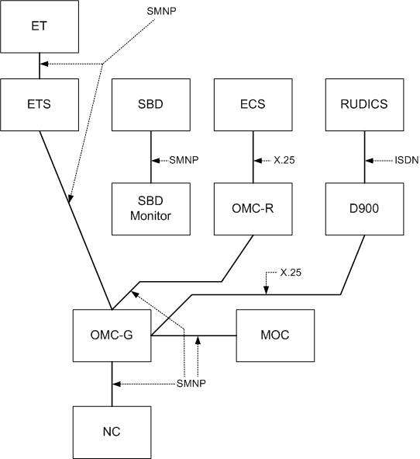

Iridium Network Fault Monitoring Diagram

2.5.3 AES Requirements
Original Requirement(s):
The AES shall meet the relevant performance requirements contained in 4.6.4 and 4.6.5 for aircraft in straight and level flight throughout the designated operational coverage of the satellite system.
[AMS(R)S SARPs, 4.6.3.1]

Recommendation.— The AES should meet the relevant performance requirements contained in 4.6.4 and 4.6.5 for aircraft attitudes of +20/-5 degrees of pitch and +/- 25 degrees of roll throughout the DOC of the satellite system. [AMS(R)S SARPs, 4.6.3.1.1]

Requirement Validation:
Validation Methods = Validation shall be provided in each sub-section of sections 2.5.4 and 2.5.5 for straight and level flight, FT (including F-16 and sounding rocket flights) for demonstration of functionality at the recommended pitch and roll attitudes
Validation Details:
It is expected that the AES’s, which utilize the Iridium-provided L Band Transceiver (LBT), shall be capable of maintaining the link with the satellites at straight and level flight, as well as during high pitch and roll angle flight, throughout the global coverage area.
Each AES (SDU) uses an Iridium Satellite-provided LBT designed and built to Iridium Satellite specifications. This approach provides consistent linkage between the AES and the satellite constellation.
Iridium LBT’s have been installed on various aircraft, including high-performance fighter aircraft and sounding rockets.
Further validation of the ability of AES equipment to meet sections 4.6.4 and 4.6.5 of the SARP’s shall be demonstrated during acceptance testing.
There are four levels of acceptance testing required for the AES equipment
- Avionics Manufacturer system testing (lab, ground and flight test)
- Iridium Satellite testing
- Safety Service SP testing
- Aeronautical terrestrial network SP (e.g., ARINC and SITA) (Data only)
During the installation of the Iridium system aboard aircraft, it is usual practice to conduct both ground safety of flight testing and flight testing where the Iridium system is tested during higher than normal flight attitudes to insure the system functions properly while maintaining safety of flight.

Background
Flight Tests were conducted with an Iridium system installed on an F-16 and NASA sounding rockets. Test results demonstrated the Iridium system maintained service through a complete 360 degree roll, with voice dropping out when the airplane was flying upside down (180 degrees), plus or minus 60 degrees. Upon rolling out of the inverted position, the voice service was restored, without having to re-establish a new call.
Flight Tests were also conducted on a NASA sounding rocket which was flown in a nearly straight up (90 degrees) attitude, plus or minus 45 degrees. Test results demonstrated the Iridium SDU maintained service during the entire flight profile.
These two flight tests demonstrated the Iridium systems can provide service at extreme pitch and roll conditions.

2.5.4 Packet Data Service Performance
2.5.4.1 Packet Data Service Performance
Original Requirement(s):
If the system provides AMS(R)S packet data service, it shall meet the standards of the following sub-paragraphs.

Note. – System performance standards for packet data service may also be found in RTCA Document DO-270.
[AMS(R)S SARPs, 4.6.4.1]

2.5.4.1.1 Sub-Network of the ATN
An AMS(R)S system providing a packet-data service shall be capable of operating as a constituent mobile sub-network of the ATN.

Note. – In addition, an AMS(R)S may provide non-ATN data functions.
[AMS(R)S SARPs, 4.6.4.1.1]

Requirement Validation:
Validation Methods = A, MN

Validation Details:
The Iridium Sub-network is capable of operating as a constituent sub-network. It shall be implemented when ICAO defines the ATN interface. The Iridium sub-network coupled with the avionics, which are harmonized with the safety service SP ground processor provides
- encapsulation of messages to allow for seamless transport of character or bit oriented messages. ATN uses bit oriented protocol
- ICAO 24-bit address
The AMS(R)S SARPs require that an AMS(R)S system providing a packet-data service shall be capable of operating as a constituent mobile sub-network of the ATN. The role of the ATN is to define an environment within which reliable end-to-end data transfer may take place, spanning the airborne, air/ground and ground-based data subnetworks while providing interoperability among those networks. The Iridium Satellite Network supports the transparent transfer of data between adjacent internetwork entities. This includes the transparent transfer of global ATN addresses and quality of service information, as well as user data. The AMS(R)S subnetwork interface to an ATN router occurs within the ATN network layer, thus control information for the data link and physical layers is not passed from subnetwork to subnetwork. Hence, the subnetwork may utilize non-ATN conforming protocols within these layers while maintaining ATN protocol architecture conformance within the network layer. Whilst it is not strictly required to adopt a common standard subnetwork interface protocol for all air/ground subnetworks, it greatly simplifies the implementation and validation of the internetwork process since only a single communication software package is required to service the interface with the different air/ground subnetworks. The ISO 8208 packet level protocol has been adopted as the standard for this interface. A subnetwork interface protocol for an Iridium AMS(R)S has not yet been specified by ICAO. Thus, compliance of the Iridium Satellite Network with AMS(R)S SARPs requires the specification and development of an appropriate subnetwork interface protocol. [AMS(R)S SARPs 4.6.4.1.1]
The Iridium RUDICS and SBD data services are advantageous for different AMS(R)S application. RUDICS offers the shortest call establishment time among all standard Iridium circuit-switch data services. SBD, though also based on circuit switch channel, offers a data transport service which has a number of characteristics very similar to a packet data call.
The following performance parameters are based on statistics accumulated over many years of Iridium Satellite Network operation. The chart in Figure 2-1 is based on measured SBD establishment delay data, both AES to Ground and Ground to AES. Figures 2-2 and 2-3 are based on measured RUDICS data, ground to AES and AES to Ground, respectively. The data were collected using auto-dialers. These charts show the data plotted over time (establishment delay) vs. percentages of total calls.
The Iridium data service RUDICS is based on circuit-switch mode. Data circuit is established and the channel stays up until the connection is torn down. The connection establishment time for a RUDICS call ranges from 10-14 sec. Once the circuit is established, the channel provides a reliable transport service of 2.4 kbps as a minimum with a more typical throughput around 2.6 kbps.
Since the Iridium SBD service utilizes only the Access phase of the normal Iridium call establishment, it does not traverse the full path of the Iridium Gateway to the switch and hence has a shorter call establishment delay. SBD call can send data immediately as soon as the Acquisition process is completed, which on average is about 1.5 sec. Therefore, the average call establishment time is about 1.5 sec for AES to ground (MO) SBD and 3.6 sec for ground to AES (MT) SBD, assuming an average RING alert duration of 2.1 sec in a typical operating environment. Since SBD utilizes the signalling channel payload (with FEC protection) rather than the normal traffic channel payload, its average throughput is less than that of standard Iridium data services such as RUDICS and is around 1.2 kbps.
Since the Iridium Satellite Network provides AMS(R)S packet data service it is expected to meet the delay and integrity requirements as stated below. [AMS(R)S SARPs 4.6.4.1]
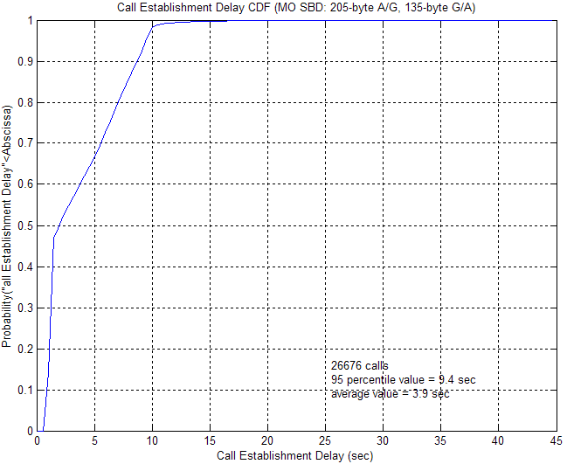
Measured SBD Call Establishment Delay (G/A and A/G)
Figure 2-1
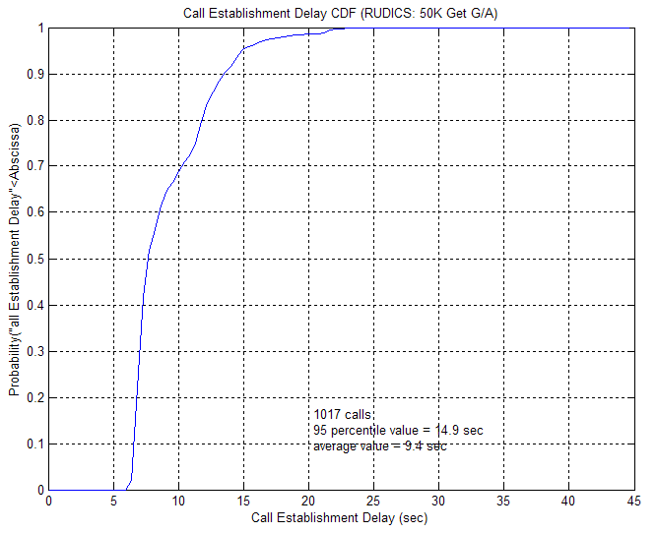
Measured RUDICS Ground to AES Call Establishment Delay
Figure 2-2
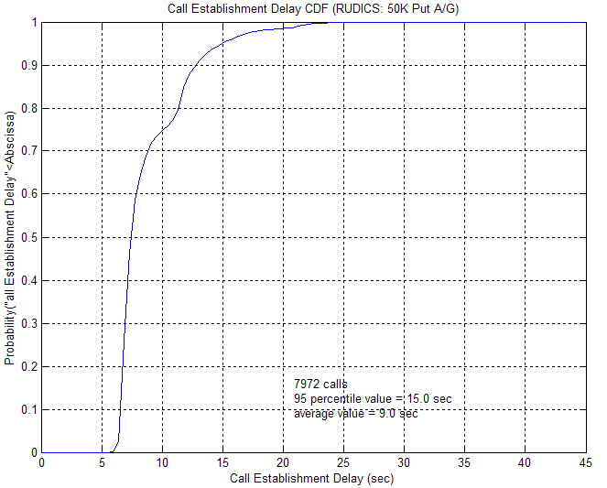
Measured RUDICS AES to Ground Call Establishment Delay
Figure 2-3

2.5.4.1.2 Delay Parameters

Note. – The term “highest priority service” denotes the priority which is reserved for distress, urgency, and certain infrequent network system management messages. The term “lowest priority service” denotes the priority used for regularity of flight messages. All delay parameters are under peak-hour traffic loading conditions.

2.5.4.1.2.1 Connection Establishment Delay
Original Requirement(s):
Connection establishment delay shall not be greater than 70 seconds
[AMS(R)S SARPs, 4.6.4.1.2.1]

2.5.4.1.2.1.1 Recommendation – Connection establishment delay should not be greater than 50 seconds.
[AMS(R)S SARPs, 4.6.4.1.2.1.1]

Requirement Validation:
Validation Methods = MN

Validation Details:
Based on accumulated Iridium satellite network performance statistics, the connection establishment delay of a RUDICS based packet data call is expected to be less than 30 sec.; the connection establishment delay of a SBD based packet data call is expected to be less than 9 sec. Refer to Figures 2-1, 2-2 and 2-3 for measured results. Measurements presented cover peak-hour traffic conditions.

2.5.4.1.2.2 Sub-network Service Data Unit (SNSDU)
Original Requirement(s):
In accordance with ISO 8348, data transit delay values shall be based on a fixed sub-network service data unit (SNSDU) length of 128 octets. Data transit delays shall be defined as average values.
[AMS(R)S SARPs, 4.6.4.1.2.2]

2.5.4.1.2.3 Data Transit Delay, from-aircraft, highest priority
Original Requirement(s):
From-aircraft data transit delay shall not be greater than 40 seconds for the highest priority data service.
[AMS(R)S SARPs, 4.6.4.1.2.3]

2.5.4.1.2.3.1 Recommendation. – Data transit delay, from-aircraft, highest priority. From-aircraft data transit delay should not be greater than 23 seconds for the highest priority data service.
[AMS(R)S SARPs, 4.6.4.1.2.3.1]

2.5.4.1.2.3.2 Recommendation. – Data transit delay, from-aircraft, lowest priority. From-aircraft data transit delay should not be greater than 28 seconds for the lowest priority data service.
[AMS(R)S SARPs, 4.6.4.1.2.3.2]

Requirement Validation:
Validation Methods = A, MN

Validation Details:
With a sub-network service data unit (SNSDU) length of 128 octets, the Iridium satellite sub-network supports the following data transit delay values:
For RUDICS based packet data service, the expected data transit delay (average transfer delay) of a 128-byte payload is 128x8/2400 = 0.43 sec. For SBD-based packet data service, the expected data transit delay of a 128-byte message is 128x8/1200 = 0.86 sec. Hence, the data transit delay of the highest priority packet is expected to be less than 5 sec. regardless if it is from AES or GES (to the AES). Refer to Figures 2-4 and 2-5 which are measured results.

2.5.4.1.2.4 Data Transit Delay, to-aircraft, highest priority
Original Requirement(s):
To-aircraft data transit delay shall not be greater than 12 seconds for the highest priority data service.
[AMS(R)S SARPs, 4.6.4.1.2.4]
2.5.4.1.2.4.1 Recommendation. – Data transit delay, to-aircraft, lowest priority. To-aircraft data transit delay should not be greater than 28 seconds for the lowest priority data service.
[AMS(R)S SARPs, 4.6.4.1.2.4.1]

Requirement Validation:
Validation Methods = A, MN

Validation Details:
With a SNSDU length of 128 octets, the Iridium satellite subnetwork supports the following data transit delay values:
For RUDICS based packet data service, the expected data transit delay (average transfer delay) of a 128-byte payload is 128x8/2400 = 0.43 sec. For SBD-based packet data service, the expected data transit delay of a 128-byte message is 128x8/1200 = 0.86 sec. Hence, the data transit delay of the highest priority packet is expected to be less than 5 sec. regardless if it is from AES or GES (to the AES). Refer to Figures 2-4 and 2-6 which are measured results.

2.5.4.1.2.5 Data Transfer Delay ( 95th percentile), from-aircraft, highest priority
Original Requirement(s):
From-aircraft data transfer delay (95th percentile), shall not be greater than 80 seconds for the highest priority data service.
[AMS(R)S SARPs, 4.6.4.1.2.5]

2.5.4.1.2.5.1 Recommendation. – Data transfer delay (95th percentile), from-aircraft, highest priority. From-aircraft data transfer delay (95th percentile) should not be greater than 40 seconds for the highest priority data service.
[AMS(R)S SARPs, 4.6.4.1.2.5.1]

2.5.4.1.2.5.2 Recommendation. – Data transfer delay (95th percentile), from-aircraft, lowest priority. From-aircraft data transfer delay (95th percentile) should not be greater than 60 seconds for the lowest priority data service.
[AMS(R)S SARPs, 4.6.4.1.2.5.2]

Requirement Validation:
Validation Methods = A, MN

Validation Details:
Based on the earlier discussion and measured results, the 95th percentile transfer delay is expected to be less than 15 seconds for the highest priority data service whether it is from-aircraft or to-aircraft.
The chart in Figure 2-4 is based on measured SBD establishment delay data, both AES-to-Ground and Ground-to-AES. Figure 2-5 is based on measured AES-to-Ground RUDICS data. The data were collected using auto-dialers. These charts show the data plotted over time (transfer delay) versus percentages of total calls.
[AMS(R)S SARPs, 4.6.4.1.2.5, 4.6.4.1.2.6]
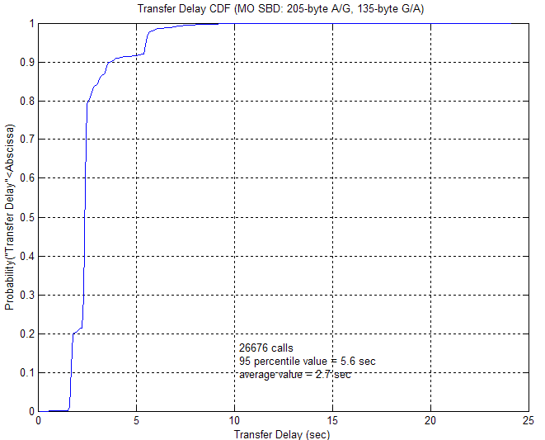
Measured SBD Data Transfer Delay (AES-to-Ground and Ground-to-AES)
Figure 2-4
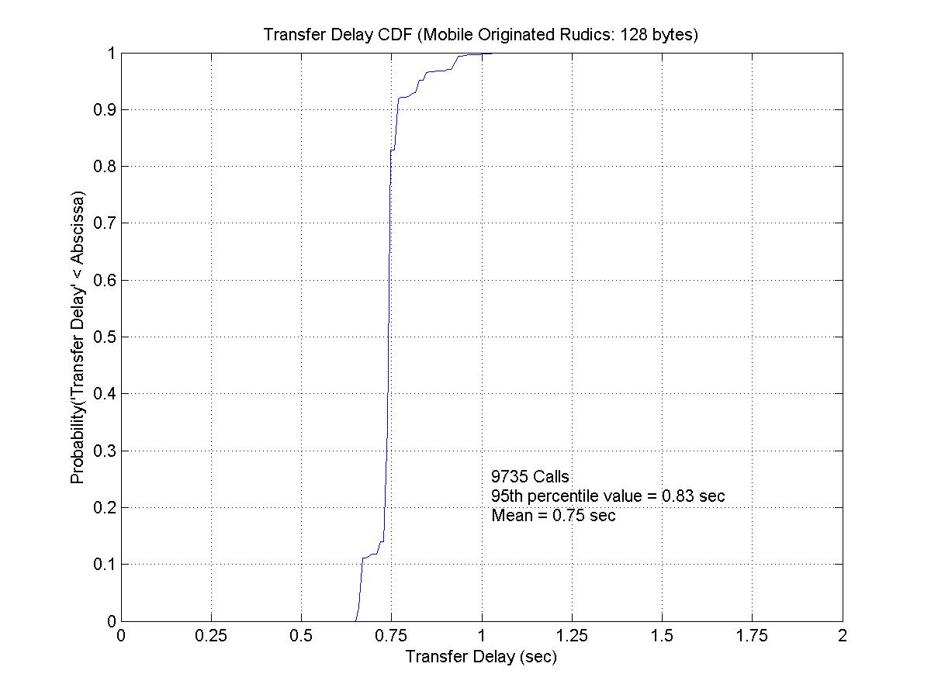
Measured RUDICS Data Transfer Delay (AES-to-Ground)
Figure 2-5

2.5.4.1.2.6 Data Transfer Delay, 95th percentile, to-aircraft, highest priority
Original Requirement(s):
To-aircraft data transfer delay (95th percentile) shall not be greater than 15 seconds for the highest priority service.
[AMS(R)S SARPs, 4.6.4.1.2.6]

2.5.4.1.2.6.1 Recommendation. – Data transfer delay (95th percentile), to aircraft, lowest priority. To-aircraft data transfer delay (95th percentile) should not be greater than 30 seconds for the lowest priority service.
[AMS(R)S SARPs, 4.6.4.1.2.6.1]

Requirement Validation:
Validation Methods = A, MN

Validation Details:
Based on the earlier discussion and the average data transfer delay value, therefore the 95th percentile data transfer delay should be less than 15 seconds for the highest priority data service whether it is from-aircraft or to-aircraft.
Refer to Figure 2-4 for SBD establishment delay data, both AES-to-Ground and Ground-to-AES. Figures 2-6 is based on measured Ground-to-AES RUDICS data. The data were collected using auto-dialers. These charts show the data plotted over time (transfer delay) vs. percentages of total calls.
[AMS(R)S SARPs, 4.6.4.1.2.5, 4.6.4.1.2.6]

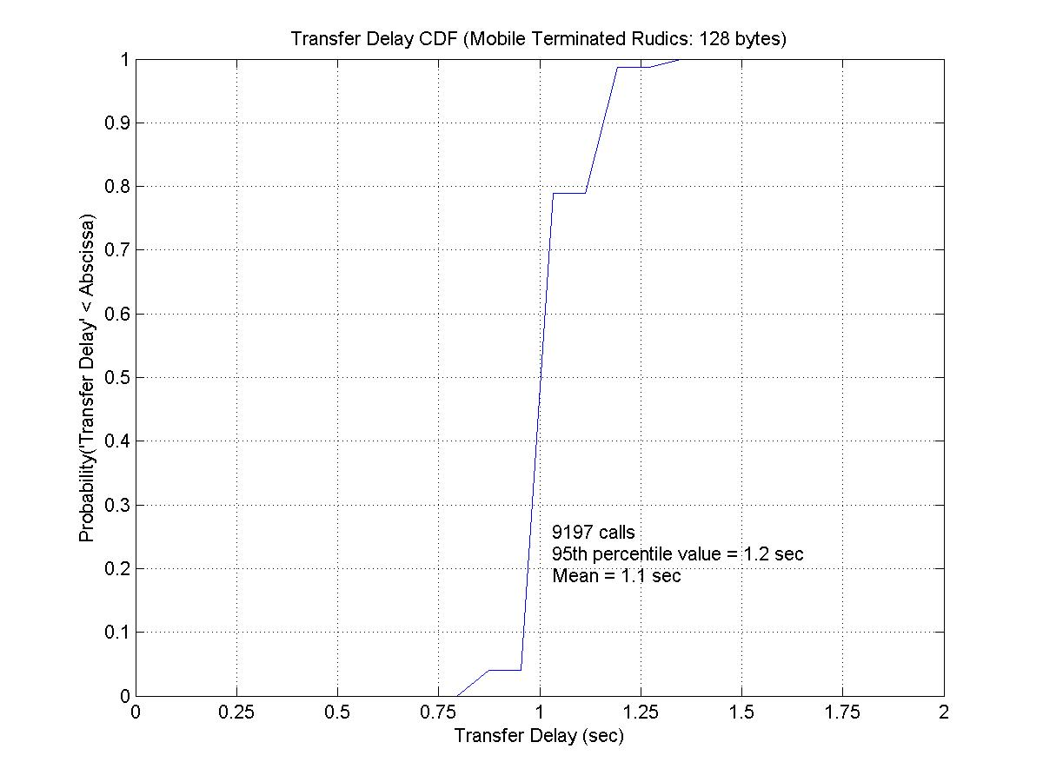
Measured RUDICS Data Transfer Delay (Ground-to-AES)
Figure 2-6

2.5.4.1.2.7 – Connection Release Delay, 95th percentile
Original Requirement(s):
The connection release delay (95th percentile) shall not be greater than 30 seconds in either direction.
[AMS(R)S SARPs, 4.6.4.1.2.7]

2.5.4.1.2.7.1 Recommendation. – The connection release delay (95th percentile) should not be greater than 25 seconds in either direction.
[AMS(R)S SARPs, 4.6.4.1.2.7.1]

Requirement Validation:
Validation Methods = A, MN

Validation Details:
Based on operational experience and performance statistics, most calls are released within 2 sec. Hence, connection release delay for all calls should be less than 5 sec. The chart in Figure 2-7 is based on measured SBD connection release delay times, both AES-to-Ground and Ground-to-AES. Figures 2-8 and 2-9 are based on measured RUDICS connection release delay times, Ground-to-AES and AES-to-Ground, respectively. The data were collected using auto-dialers. These charts show the data plotted over time (connection release delay) vs. percentages of total calls.

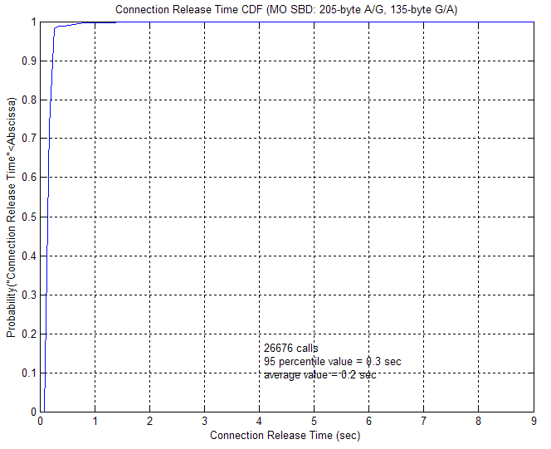
Measured SBD Connection Release Delay (AES-to-Ground and Ground-to-AES)
Figure 2-7
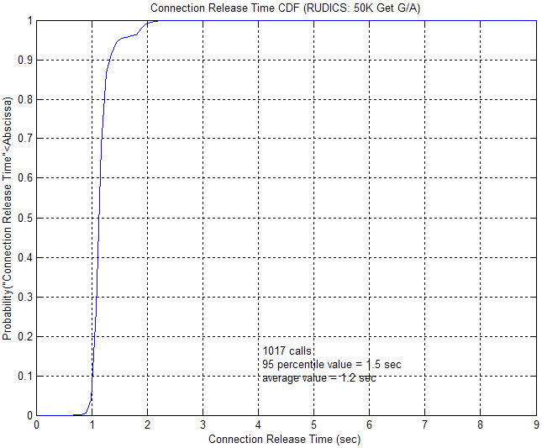
Measured RUDICS Connection Release Delay (Ground-to-AES)
Figure 2-8

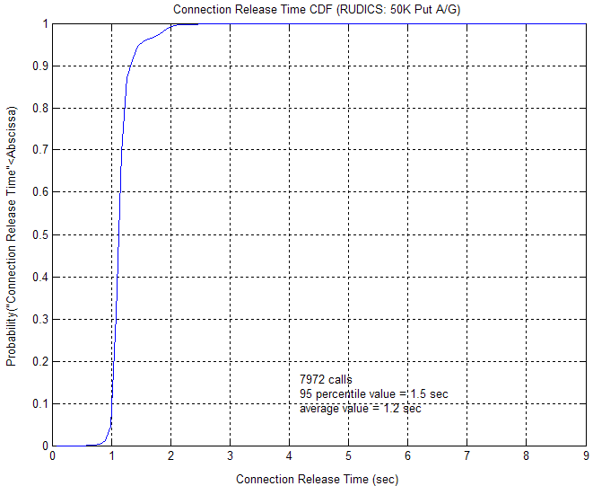
Measured RUDICS Connection Release Delay (AES-to-Ground)
Figure 2-9

2.5.4.1.3 Integrity

2.5.4.1.3.1 Residual error rate, from-aircraft
Original Requirement(s):
The residual error rate in the from-aircraft direction shall not be greater than 10⁻⁴ per SNSDU.
[AMS(R)S SARPs, 4.6.4.1.3.1]

2.5.4.1.3.1.1 Recommendation. – The residual error rate in the from-aircraft direction should not be greater than 10⁻⁶ per SNSDU.
[AMS(R)S SARPs, 4.6.4.1.3.1.1]

2.5.4.1.3.2 Residual error rate, to-aircraft
Original Requirement(s):
The residual error rate in the to-aircraft direction shall not be greater than 10⁻⁶ per SNSDU.
[AMS(R)S SARPs, 4.6.4.1.3.2]

Requirement Validation:
Validation Methods = A; I_{B;} Reference Annex B, WP-599

Validation Details:
Iridium’s data services employ the same error detection and error correction protocols to and from aircraft.

The AMS(R)S SARPs specify packet data service integrity by residual error rate. It further defines residual error rate as the combination of the probabilities of undetected error, of undetected loss of a sub-network service data unit (SNSDU) and of an undetected duplicate SNSDU.

Regarding probabilities of undetected loss and undetected duplicate, both the Iridium circuit switch data transport and the Iridium SBD protocol employ message sequence number and automatic repeat request (ARQ) retransmission at the Iridium protocol data unit (PDU) level. For SBD, message sequence number (MSN) is also applied at the SNSDU level. These mechanisms will ensure that the required probabilities for undetected loss and undetected duplicate of an SNSDU can be met.

Probability of undetected error is the packet error rate.

RUDICS employs a 24-bit frame check sequence, and the user payload field in an Iridium PDU is 248 bits. To transport a 128-byte data packet, it will take 5 Iridium PDUs. Analysis indicates the probability of a 128-byte data packet in error is about 3x10⁻⁷.
Refer to Annex B, WP-599, Table 1, Acceptability Criteria Working Table, Ref. S, for analysis details for circuit-switched data.

The SBD service uses the Iridium signalling channel for data transport and is a guaranteed delivery service with multiple layers of error protection. It employs forward error control in the form of BCH coding in addition to selective ARQ. By design, the SBD data transport has a better packet error rate performance than the circuit switch data transport.

Calculation of the residual error rate for SBD requires understanding the special message delivery protocol employed by SBD, which is separate than that used for circuit-switched data calls. This protocol results in each Iridium TDMA burst consisting of 160 SBD information bits, 20 SBD header bits and 234 other overhead bits. These 160 information bits are protected by a BCH(31,20) FEC code. This error correction coded data is then protected by a 16-bit CRC error detection code that is used in conjunction with a selective ARQ process.

The word error performance of a double-error correcting BCH(31,20) code is found as:
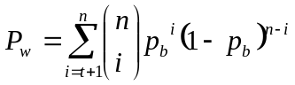, (Eq. 1)
where P_{w} is the word error probability, t is the error correcting capability of the code (=2), n is the code word length (=31) and p_{b} is the channel bit error probability. For the minimum Iridium channel bit error rate specification of 10⁻², substituting in the above values yields P_{w} = 3.65x10⁻³.

At the output of the BCH decoding process, there are ten, 20-bit words (one header word, eight data words and one CRC word) that make up one SBD PDU being fed to the CRC-16 decoding process. The probability that none of these ten, 20-bit words has an error in it is found as
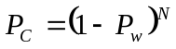, (Eq. 2)

where N is the total number of words being fed into the CRC-16 decoder and in this case is 208. Using this and the value of P_{w} above, we find P_{C} = 0.964

CRC-16 error detection codes have well-known capabilities, which include the ability to detect all single and double bit error combinations (as well as other combinations). Assuming there are errors, the probability of the CRC-16 code failing to detect these errors is given as 2⁻¹⁶. An upper bound for estimating the probability of an undetected SBD PDU error would then be the product of the probability that there is still at least one error at the output of the BCH error decoding process (1 – P_{C}) and the probability that these uncorrected errors are also undetected by the CRC-16 decoder:
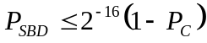. (Eq. 3)
After substituting the value for P_{C} above, the probability of an undetected SBD PDU, P_{SBD}, is found as 5.47x10⁻⁷. It should be noted that this is an upper bound since:
- The (1 – P_{C}) factor includes single and double bit error combinations which the CRC-16 decoding process will detect, and
- The above analysis is calculated at receiver threshold (i.e., none of the Iridium 16 dB link margin is available).

The above value for P_{SBD} is valid for both the aircraft transmit and receive directions.

It is expected that Iridium AMS(R)S packet data can provide a residual error rate no greater than 10⁻⁶ per SNSDU, whether it is from-aircraft or to-aircraft.

2.5.4.1.3.3 Connection resilience
Original Requirement(s):
The probability of a subnetwork connection (SNC) provider-invoked SNC release shall not be greater than 10⁻⁴ over any one-hour interval.

Note. – Connection releases resulting from GES-to-GES handover, AES log-off or virtual circuit preemption are excluded from this specification.
[AMS(R)S SARPs, 4.6.4.1.3.3]

Requirement Validation:
Validation Methods = A

Validation Details:
An ACARS air/ground subnetwork does not support priority distinctions among messages. However, external entities (e.g., an ACARS MU having multiple data input/output ports) can arrange the precedence of messages presented to the air/ground subnetwork for transmission, in accordance with the implied priority level associated with each port. Such an arrangement is incorporated in the architecture of FANS-1/A applications. FANS 1/A data links implement the mechanisms described above and have additional features to support certain ATS applications. The environment application interfaces support most ATN-compliant applications by emulating the ISO 8072 Transport Service. The application interface, in effect, provides a convergence function between the connection-oriented ISO 8072 Transport Service Interface and the connectionless ACARS protocol beneath it.

Iridium connection resilience tests were conducted using auto-dialers that placed continuously running, 45-second calls. Dropped call statistics were collected on a daily basis for one year. The daily dropped call rate averaged 0.33%. Dropped calls resulted from phone and network issues, in addition to any RF-related issues.

Note: The application interface is referred to as “field application” within the Technical and Implementation Manual.

          - SNC provider-invoked reset
Original Requirement(s):
The probability of an SNC provider-invoked reset shall not be greater than 10⁻¹ over any one-hour interval.
[AMS(R)S SARPs, 4.6.4.1.3.4]

Requirement Validation:
Validation Methods = N/A

Validation Details:
Iridium does not invoke resets of any kind to terminal equipment. This requirement does not apply.

2.5.5 Voice Service Performance

2.5.5.1 Voice Service Performance
Original Requirement(s):
If the system provides AMS(R)S voice service, it shall meet the requirements of the following sub-paragraphs.
[AMS(R)S SARPs, 4.6.5.1]

Note. – ICAO is currently considering these provisions in light of the introduction of new technologies.

Requirement Validation:
Validation Methods = per each sub-paragraph’s requirement validation

Validation Details:
Validation will be on a per sub-paragraph basis

2.5.5.1.1 Call processing delay

2.5.5.1.1.1 AES origination
Original Requirement(s):
The 95th percentile of the time delay for a GES to present a call origination event to the terrestrial network interworking interface after a call origination event has arrived at the AES interface shall not be greater than 20 seconds.
[AMS(R)S SARPs, 4.6.5.1.1.1]

Requirement Validation:
Validation Methods = A, MN

Validation Details:
Based on Iridium satellite network operational experience and performance statistics, most mobile-originated and mobile-terminated voice calls take 12 sec and 14 sec to set up, respectively.

The chart in Figure 2-10 is based on measured AES-to-Ground call establishment delay data. The data was collected using auto-dialers. This chart shows the data plotted over time (transfer delay) vs. percentages of total calls.

For Iridium AMS(R)S, the 95th percentile of the time delay for a GES to present a call origination event to the terrestrial network interworking interface after a call origination event has arrived at the AES is not expected to be greater than 20 seconds. [AMS(R)S SARPs, 4.6.5.1.1.1]

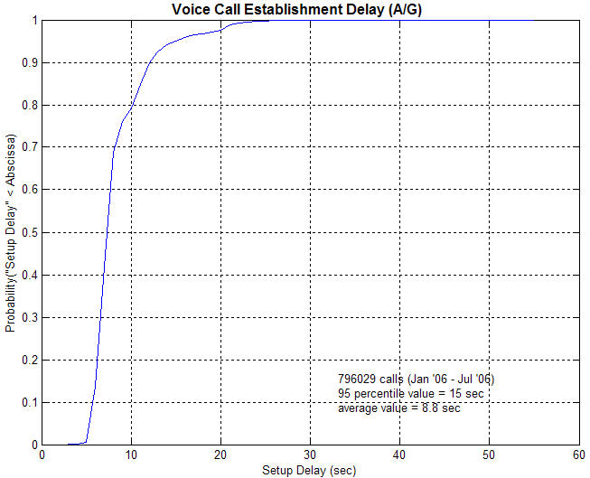
Measured Voice Call Establishment Delay (AES-to-Ground)
Figure 2-10

2.5.5.1.1.2 GES origination
Original Requirement(s):
The 95th percentile of the time delay for an AES to present a call origination event at its aircraft interface after a call origination event has arrived at the terrestrial network interworking interface shall not be greater than 20 seconds.
[AMS(R)S SARPs, 4.6.5.1.1.2]

Requirement Validation:
Validation Methods = MN

Validation Details:
Based on Iridium satellite network operational experience and performance statistics, most mobile-originated and mobile-terminated voice calls take 12 sec and 14 sec to set up, respectively.
For Iridium AMS(R)S, the 95th percentile of the time delay for an AES to present a call origination event at its aircraft interface after a call origination event has arrived at the terrestrial network interworking interface is expected to not be greater than 20 seconds. [AMS(R)S SARPs, 4.6.5.1.1.2]
Measurement of GES originated call establishment delay without going through the public switched telephone network (PSTN) presents a challenge. Therefore, an alternative measurement method has been conducted. First, call establishment delay statistics were collected for mobile-to-mobile calls within the Iridium network. These measurements include call origination and call termination establishment delays, but do not consist of any PSTN delays, since mobile-to-mobile calls take place completely within the Iridium network. Next, delay data was collected for mobile originated calls that were terminated at an automated call termination function at the back end of the Iridium switch. These delay measurements include call origination delay and, again, do not consist of any PSTN delay, since the call is originated and terminated within the Iridium network. The resulting GES origination delay to the AES terminal can then be calculated as the mobile-to-mobile call establishment delay, minus the mobile-to-switch establishment delay.
The chart in Figure 2-11 is based on measured Ground-to-AES call establishment delay data. The data was collected using auto-dialers.

Insert Chart here

Measured Voice Call Establishment Delay (Ground-to-AES)
Figure 2-11

2.5.5.1.2 Voice Quality

2.5.5.1.2.1 Overall intelligibility
Original Requirement(s):
The voice transmission shall provide overall intelligibility performance suitable for the intended operational and ambient noise environment.
[AMS(R)S SARPs, 4.6.5.1.2.1]

Requirement Validation:
Validation Methods = FT, MN

Validation Details:
The ISLLC test plan includes voice quality testing, including mean opinion scoring. The test plans of safety service SPs are expected to include voice quality testing for any unique aircraft configurations not covered by ISLLC testing.
The Iridium SDU incorporates a 2.4 kbps Advanced Multi-Band Excitation (AMBE) vocoder developed by Digital Voice System Inc. (DVSI). This vocoder is tailored to the Iridium communication channel and provides good quality audio performance with a nominal Mean Opinion Score (MOS) of 3.5 under typical non-aeronautical operating and channel conditions.
As Iridium terminals have been installed and successfully operated on various types of aircrafts including helicopters, it is expected that Iridium will meet requirements for overall intelligibility.

2.5.5.1.2.2 Transfer delay
Original Requirement(s):
The total allowable transfer delay within an AMS(R)S subnetwork shall not be greater than 0.485 second.
[AMS(R)S SARPs, 4.6.5.1.2.2]

2.5.5.1.2.3 Other effects on voice quality
Recommendation. – Due account should be taken of the effects of tandem vocoders and/or other analog/digital conversions.
[AMS(R)S SARPs, 4.6.5.1.2.3]

Requirement Validation:
Validation Methods = I_{B;} Reference Annex B, WP-599

Validation Details:
For the Iridium AMS(R)S voice service, a total voice call transfer delay within the AMS(R)S subnetwork of no greater than 0.375 second can be expected. Refer to Annex A, WP-599, Table 1, Ref R.

2.5.5.1.3 Voice Capacity
2.5.5.1.3.1 Voice capacity
Original Requirement(s):
The system shall have sufficient available voice traffic channel resources such that an AES- or GES-originated AMS(R)S voice call presented to the system shall experience a probability of blockage of no more than 10⁻².

Note. – Available voice traffic channel resources include all pre-emptable resources, including those in use by non-AMS(R)S communications.
[AMS(R)S SARPs, 4.6.5.1.3.1]

Requirement Validation:
Validation Methods = A

Validation Details:
Based on the Communications Operating Concept and Requirements (COCR Study) for the Future Radio System, version 1.0, commissioned by the FAA and EuroControl, it is expected that Iridium AMS(R)S will have sufficient available voice traffic channel resources for oceanic and remote operations for both Phase 1 and 2 (projected out past the year 2025) such that an AES- or GES-originated AMS(R)S voice call presented to the system shall experience a probability of blockage of no more than 10⁻².
Tables 6-17 and 6-18 of the COCR study provide Phase 1 and Phase 2 summaries of voice capacity requirements for four different service areas: airport (APT), terminal maneuvering area (TMA), en route (ENR) and oceanic, remote, polar (ORP). Included in these tables is the time to traverse a given service area. If an aircraft speed is assumed (250 knots for aircraft in the APT and TMA areas and 650 knots for the ENR and ORP areas), then an estimate of service area diameter can be found. This service area size can then be compared with the coverage area of an Iridium spot beam. Since the number of supported traffic channels within an Iridium spot beam is known, a determination can be made of whether the required voice traffic capacities can be met by Iridium.

 | APT |  | TMA |  | ENR |  | ORP
 | HD | LD | HD | LD | HD | LD | HD | LD
Flight duration through service area (sec)¹ | 870 | 450 | 334 | 519 | 675 | 900 | 2550 | 2550
Service area diameter (nmi)² | N/A | N/A | N/A | N/A | 122 | 163 | 460 | 460
Approximate no. of service areas within Iridium spot beam³ | 10 | 10 | 10 | 10 | 3 | 2 | 1 | 1
Traffic per service area (ccs/hr)⁴ | 94.63 | 22.18 | 23.02 | 12.94 | 34.93 | 15.33 | .34 | .17
Traffic per Iridium spot beam (ccs/hr) | 947 | 222 | 230 | 130 | 105 | 31 | 0.34 | 0.17
Number of circuits required to meet traffic load, for GOS = 1%⁵ | 37 | 13 | 13 | 9 | 8 | 4 | 1 | 1
Table 2-2: Voice Capacity Requirements

Notes:
1. Flight duration obtained directly from Table 6-17 of the COCR report.
2. For ENR and ORP regions, the service area size was calculated by multiplying average aircraft speed of 650 knots by flight duration. For the APT and TMA regions, service area cannot be found from flight duration, since aircraft are on ground.
3. For ENR and ORP regions, the number of service areas per spot beam was found by dividing the area of a 216 nmi (400 km) diameter spot beam by the service area. For APT and TMA regions, an extreme limit of 10 such airports per spot beam was assigned.
4. The traffic data was obtained directly from call-second data from Table 6-17 of the COCR report, and divided by 100 to get cent-call-seconds (ccs).
5. The number of circuits was obtained from Erlang B tables, which provide the number of circuits needed to support a given traffic loading at a given grade-of-service (GOS). The SARPs have defined GOS = 1%.

The data provided in Table 2-2 is derived from Phase 1 capacity requirements from the COCR report. The Phase 2 requirements are actually less stringent than for Phase 1, so a capacity analysis using Phase 2 requirements is not necessary.

Iridium currently has at least 184 duplex frequency channels, with 4 user timeslots per channel, for a total of 736 circuits available across the system. The resulting number of required circuits as determined in Table 2-2 above is well below Iridium’s capacity capability.

2.5.6 Security

2.5.6.1 Protection of Messages
Original Requirement(s):
The system shall provide features for the protection of messages in transit from tampering.
[AMS(R)S SARPs, 4.6.6.1]

Requirement Validation:
Validation Methods = A

Validation Details:
The Iridium Satellite Network, being an operational satellite service, employs various security measures against external attack and tampering.

Iridium Channel Security
The complexity of the Iridium network air interface makes message interception or tampering very difficult:

To successfully monitor an L-band channel, an eavesdropper must be located within the transmit range of the SDU being monitored, approximately 10 to 30 km from the transmitting SDU in a ground-use scenario and approximately 250 to 350 km from an AES in flight. SDU downlink L-Band transmissions could be received over a much wider area. A single satellite beam covers an area of about 400 km in diameter.

Air Interface
The complexity of the Iridium air interface would make the challenge of developing an Iridium L-Band monitoring device very difficult. Among the complications are:
- Iridium’s air interface is proprietary
- Large, continually changing Doppler shifts
- Frequent inter-beam and inter-satellite handoffs
- Time-division multiplexed burst mode channels
- Complicated modulation, interleaving and coding

Feederlink Interface
A sophisticated monitoring device would be needed in the general proximity of an Iridium gateway to receive the feederlink channel. The complexity of the feederlink interface poses a formidable technical challenge for prospective eavesdroppers. Among the technical complications are:
- Large, continually changing Doppler shifts
- High capacity, ~3 Mbps channels
- High-gain tracking antenna required
- Must reacquire new satellite every 10 minutes

Fraud Protection
Fraud Protection is provided during the Access process. During this process, the gateway determines if the requesting SDU is providing its own geographical location. If true, the system requests a check of the geographical location provided by the requesting SDU with the Beam ID the SDU is using. If the beam coverage location associated with the Beam ID does not match with the SDU-provided location, the system sets a fraud flag. The system then sends the SDU the “Access Decision Notification” message with the indicator set to “access denied” and service is denied, with the exception of emergency calls.

The Iridium authentication process is adapted without change directly from GSM specifications.

It is expected that these security measures employed by the Iridium Satellite Network will provide a high level of protection of messages in transit from tampering. [AMS(R)S SARPs, 4.6.6.1]

Note: There is nothing to prevent encryption at the field application level.

2.5.6.2 Protection Against External Attacks on Service
Original Requirement(s):
The system shall provide features for protection against denial of service, degraded performance characteristics, or reduction of system capacity when subjected to external attacks.

Note.— Possible methods of such attack include intentional flooding with spurious messages, intentional corruption of system software or databases, or physical destruction of the support infrastructure.
[AMS(R)S SARPs, 4.6.6.2]

Requirement Validation:
Validation Methods = A

Validation Details:
Refer to section 2.5.6.1 for additional measures for protection against external attacks. Beyond the Iridium authentication process, access to the Iridium network would be extremely difficult as outlined below.

Physical Security
The Iridium Gateway(s), its Master Control Facility, and its Telemetry, Tracking And Control stations are all secured facilities providing protection against unauthorized entry.

These security aspects of the Iridium Satellite Network provide the same level of protection against certain types of denial of service, such as intentional flooding of traffic, as currently implemented in the GSM.

It is expected that the Iridium system will provide protection against external attacks on service due to security measures in place at its gateways and facilities, as well as built-in protections in its air interface and authentication process.

Note: Additional security measures are provided through the aviation centric networks (e.g., ARINC and SITA) which are outside the scope of this report.

2.5.6.3 Protection Against Unauthorized Entry
Original Requirement(s):
The system shall provide features for protection against unauthorized entry.

Note. – These features are intended to provide protection against spoofing and “phantom controllers”.
[AMS(R)S SARPs, 4.6.6.3]

Requirement Validation:
Validation Methods = I_{B}

Validation Details:
In order to safeguard the Iridium Satellite network, command and control of access to the Iridium constellation is limited to the Iridium Satellite Network Operations Center (SNOC) and the Iridium Technical Support Center (TSC), which access and load the constellation control software.

Secure access is provided at the SNOC and TSC including 7x24 guards (SNOC only) with multiple-door badge access restrictions and password-protected Mission LAN access; firewalled connections also are in place to protect against unauthorized access.

Outside of these sites, malicious corrupt software loading would require Iridium-specific tracking and command/control (TTAC) and Mission LAN hardware and software, which are not readily available. This equipment and software are rare and would be extremely difficult to obtain and properly configure to access the constellation.

Additionally, the probability of unauthorized personnel being able to cause permanent damage to a satellite by uploading malicious software is mitigated due to the following factors:

- Unauthorized personnel would need access to detailed information about software product upload directories, command and verification formats, etc., that are specified in detailed procedures and checklists. Without this information, malicious software would not be accepted by the satellite.

- The satellite commanding requirements are so esoteric that extensive training and practice is required before an upload can be successfully performed.

- The satellite itself has multiple computers, so that any malicious software would have to be loaded to multiple satellite computers successfully in order to do any permanent damage.

It is expected that the Iridium satellite network will provide very high levels of protection at the physical and network levels.

SYSTEM INTERFACES

2.6.1 ICAO 24-Bit Aircraft Address
Original Requirement(s):
An AMS(R)S system shall allow subnetwork users to address AMS(R)S communications to specific aircraft by means of the ICAO 24-bit aircraft address.

Note. – Provisions on the allocation and assignment of ICAO 24-bit addresses are contained in Annex 10, Volume III, Appendix to Chapter 9.
[AMS(R)S SARPs, 4.7.1]

Requirement Validation:
Validation Methods = A, UT, IT

Validation Details:
The aircraft SDU are mapped to corresponding ICAO address(es) within the ground based safety services SP processor. This is accomplished outside the Iridium sub-network. This mapping is initiated during the log-on stage, or hand-shake between the SDU and the ground based safety services SP processor.
During the FAA/ARINC CPDLC trials conducted in Miami, Florida, the service processor handling the traffic between the aeronautical (air-ground) and the terrestrial (ground-ground) networks did not support the implementation of addressing via the 24-bit ICAO address. The off-line service processor, set up in the FAA Technical center does not currently support this addressing capability. Without having such a service processor in place, testing of this capability cannot take place.
Iridium commits to supporting this feature when the ATN network is deployed with this feature.
Aircraft avionics shall be tested in accordance with safety services SP test plan for avionics prior to approval and certification as a qualified safety services system for data services.

2.6.2 Packet Data Service Interfaces

2.6.2.1 ATN interface
Original Requirement(s):
If the system provides AMS(R)S packet data service, it shall provide an interface to the ATN.

Note. – The detailed technical specification related to provisions of ATN-compliant sub-network service are contained in Section 5.2.5 and Section 5.7.2 of Doc 9705 – Manual of Technical Provisions for the Aeronautical Telecommunication Network.
[AMS(R)S SARPs, 4.7.2.1]

Requirement Validation:
Validation Methods = A

Validation Details:
The AMS(R)S SARPs require that an AMS(R)S system providing a packet-data service shall be capable of operating as a constituent mobile sub-network of the ATN. The Iridium Satellite Network supports the transparent transfer of data between adjacent internetwork entities. This includes the transparent transfer of global ATN addresses and quality of service information, as well as user data. A subnetwork interface protocol for an Iridium AMS(R)S has not yet been specified by ICAO. Thus, compliance of the Iridium Satellite Network with AMS(R)S SARPs requires the specification and development of an appropriate subnetwork interface protocol.
Iridium will work with its AMS(R)S service providers and AES manufacturers to ensure that the Iridium AMS(R)S system will allow subnetwork users to address AMS(R)S communications to specific aircraft by means of the ICAO 24-bit aircraft address. [AMS(R)S SARPs, 4.7.1] and will provide an interface to the ATN as well as a connectivity notification (CN) function. [AMS(R)S SARPs, 4.7.2.1, 4.7.2.2]
Aircraft avionics shall be tested in accordance with safety services SP test plan for avionics prior to approval and certification as a qualified safety services system for packet data services.

2.6.2.2 Connectivity notification
Original Requirement(s):
If the system provides AMS(R)S packet data service, it shall provide a connectivity notification (CN) function.
[AMS(R)S SARPs, 4.7.2.2]

Requirement Validation:
Validation Methods = A

Validation Details:
The AMS(R)S SARPs require that an AMS(R)S system providing a packet-data service shall be capable of operating as a constituent mobile sub-network of the ATN. The Iridium Satellite Network supports the transparent transfer of data between adjacent internetwork entities. This includes the transparent transfer of global ATN addresses and quality of service information, as well as user data. A subnetwork interface protocol for an Iridium AMS(R)S has not yet been specified by ICAO. Thus, compliance of the Iridium Satellite Network with AMS(R)S SARPs requires the specification and development of an appropriate subnetwork interface protocol.
Iridium will work with its AMS(R)S service providers and AES manufacturers to ensure that the Iridium AMS(R)S system will allow subnetwork users to address AMS(R)S communications to specific aircraft by means of the ICAO 24-bit aircraft address. [AMS(R)S SARPs, 4.7.1] and will provide an interface to the ATN as well as a connectivity notification (CN) function. [AMS(R)S SARPs, 4.7.2.1, 4.7.2.2]
Aircraft avionics shall be tested in accordance with safety services SP test plan for avionics prior to approval and certification as a qualified safety services system for packet data services.

Table 2-3 Iridium AMS(R)S System Parameters per ICAO AMS(R)S SARPs
AMS(R)S SARPs Reference | AMS(R)S  SARP Contents | Iridium Subnetwork Value | Additional Comments on Performance
4.2.1 | AMS(R)S shall conform to ICAO Chapter 4 | Yes | -
4.2.1.1 | Recommendation to ensure CNS protection by AMSS system | Yes | -
4.2.1.2 | Support packet data, voice, or both | Yes;  both | By design.
4.2.2 | Mandatory equipage | N/A for service provider | -
4.2.3 | 2 year's notice | N/A for service provider | -
4.2.4 | Recommendation consider worldwide implementation | Yes | -
4.3.1 | Frequency Bands | N/A | Placeholder
4.3.1.1 | Only in frequency bands allocated to AMS(R)S and protected by ITU RR | Yes;  1616-1626.5 MHz | -
4.3.2 | Emissions | N/A | Placeholder
4.3.2.1 | Limit emissions to control harmful interference on same aircraft | Yes | (M) AES emission to be measured by AES equipment manufacturer per RTCA DO-262.
4.3.2.2 | Shall not cause harmful interference to AMS(R)S on other aircraft | No | See DO-294.
4.3.2.2.1 | Emissions shall not cause harmful interference to an AES providing AMS(R)S on a different airplane | Yes | (M) AES emission to be measured by AES equipment manufacturer per RTCA DO-262.
4.3.3.1 | Shall operate properly in cumulative ΔT/T of 25% | Yes | (M) AES emission to be measured by AES equipment manufacturer per RTCA DO-262.
4.4.1 | Priority and pre-emptive access | Yes | (I) To be verified by AES manufacturer per RTCA DO-262.
4.4.2 | All AMS(R)S packets and voice calls shall be identified by priority | Yes | (I) To be verified by AMS(R)S Service Providers (SP).
4.4.3 | Within the same msg category, voice has priority over data | Yes | (I) To be verified by AMS(R)S SP.
4.5 | Signal Acquisition and Tracking | N/A | Placeholder
4.5.1 | Properly track signal for A/C at 800 kt. along any heading | Yes | Verified by operational experience.
4.5.1.1 | Recommendation for 1500 kts. | Yes | (M) To be verified by AES manufacturer.
4.5.2 | Properly track with 0.6 g acceleration in plane of orbit | Yes | Verified by operational experience.
4.5.2.1 | Recommendation 1.2 g | TBD | (M) To be verified by AES manufacturer.
4.6 | Performance Requirements | N/A | Placeholder
4.6.1 | Designated Coverage | N/A | Placeholder
4.6.1.1 | Provide AMS(R)S throughout Designated Operational Coverage | Oceanic / remote / Polar (ORP) region | Verified by operational experience.
4.6.2 | Failure Notification | N/A | Placeholder
4.6.2.1 | Provide timely predictions of service failure-induced outages | Yes | (I) By process to be set up with AMS(R)S SP.
4.6.2.2 | Within 30 s | Yes | (I) By process to be set up with AMS(R)S SP.
4.6.3 | AES Requirements |  | Placeholder
4.6.3.1 | Meet performance in straight and level flight | Yes | (I) To be verified by AES manufacturer.
4.6.3.1.1 | Recommendation for +20/-5 pitch ant +/-25 roll | TBD | (I) To be verified by AES manufacturer.
4.6.4 | Pkt Data Svc Performance | N/A | Placeholder
4.6.4.1 | Requirements on AMS(R)S packet data | Yes | See subsections.
4.6.4.1.1 | Capable of mobile subnetwork in ATN | Yes;  ISO-8028 | (I) To be verified by AMS(R)S SP when end-to-end system is implemented.
4.6.4.1.2 | Delay Parameters | N/A | Placeholder
4.6.4.1.2.1 | Connection establishment delay < 70 seconds | < 30s | Iridium subnetwork performance verified by current performance data. (M)
4.6.4.1.2.1.1 | Recommendation  Connection establishment delay < 50 seconds | < 30s | Iridium subnetwork performance verified by current performance data. (M)
4.6.4.1.2.2 | Transit delay based on SNSDU of 128 octets and defined as average values | Yes | -
4.6.4.1.2.3 | From A/C highest priority < 40 seconds | < 5s | Iridium subnetwork performance verified by current performance data. (M)
4.6.4.1.2.3.1 | Recommendation from A/C highest priority < 23 seconds | < 5s | Iridium subnetwork performance verified by current performance data. (M)
4.6.4.1.2.3.2 | Recommendation from A/C lowest priority < 28 seconds | < 10s | Iridium subnetwork performance verified by current performance data. (M)
4.6.4.1.2.4 | To A/C high priority < 12 seconds | < 5s | Iridium subnetwork performance verified by current performance data. (M)
4.6.4.1.2.4.1 | Recommendation To A/C lowest priority < 28 seconds | < 10s | Iridium subnetwork performance verified by current performance data.
4.6.4.1.2.5 | From A/C Data transfer delay 95%ile highest priority < 80 seconds | < 15s | Iridium subnetwork performance verified by current performance data. (M) End-to-end 95%ile value requires CDF statistics.
4.6.4.1.2.5.1 | Recommendation From A/C Data transfer delay 95%ile highest priority < 40 seconds | <15s | Iridium subnetwork performance verified by current performance data.  (M) End-to-end 95%ile value requires CDF statistics.
4.6.4.1.2.5.2 | Recommendation From A/C Data transfer delay 95%ile lowest priority < 60 seconds | TBD | (M) End-to-end 95%ile value requires CDF statistics.
4.6.4.1.2.6 | To A/C Data transfer delay 95%ile high priority < 15 seconds | < 8s | Iridium subnetwork performance verified by current performance data. (M) End-to-end 95%ile value requires CDF statistics.
4.6.4.1.2.6.1 | Recommendation To A/C Data transfer delay 95%ile low priority < 30 seconds | TBD | (M) End-to-end 95%ile value requires CDF statistics.
4.6.4.1.2.7 | Connection release time 95%ile < 30 seconds | < 5s | Iridium subnetwork performance verified by current performance data. (M) End-to-end 95%ile value requires CDF statistics.
4.6.4.1.2.7.1 | Recommendation connection release time 95%ile < 25 seconds | < 5s | Iridium subnetwork performance verified by current performance data. (M) End-to-end 95%ile value requires CDF statistics.
4.6.4.1.3 | Integrity | N/A | Placeholder
4.6.4.1.3.1 | Residual error rate from A/C < 10⁻⁴/SNSDU | < 10⁻⁶ | Verified by current performance data. (M)
4.6.4.1.3.1.1 | Recommend RER from A/C < 10⁻⁶/SNSDU | < 10⁻⁶ | Verified by current performance data. (M)
4.6.4.1.3.2 | RER to A/C < 10⁻⁶ /SNSDU | < 10⁻⁶ | Verified by current performance data. (M)
4.6.4.1.3.3 | Pr{SNC provider invoked release}< 10⁻⁴/hr | < 10⁻⁴/hr | (M) To be verified by AMS(R)S SP when end-to-end system is implemented.
4.6.4.1.3.4 | Pr{SNC provider invoked reset}< 10⁻¹/hr | < 10⁻¹/hr | (M) To be verified by AMS(R)S SP when end-to-end system is implemented.
4.6.5 | Voice Service Performance | N/A | Placeholder
4.6.5.1 | Requirements for AMS(R)S voice service | Yes | -
4.6.5.1.1 | Call Delay Processing | N/A | Placeholder
4.6.5.1.1.1 | AES call origination delay 95%ile < 20 seconds | < 20s | Iridium subnetwork performance verified by current performance data. (M) CDF statistics are needed for 95%ile value verification.
4.6.5.1.1.2 | GES call origination delay 95%ile < 20 seconds | < 20s | Iridium subnetwork performance verified by current performance data. (M) CDF statistics are needed for 95%ile value verification.
4.6.5.1.2 | Voice Quality | N/A | Placeholder
4.6.5.1.2.1 | Voice intelligibility suitable for intended operational and ambient noise environment | Yes | (M) To be verified by AES manufacturer.
4.6.5.1.2.2 | Total allowable transfer delay within AMS(R)S  subnetwork < 0.375 second | < 0.485s | Verified by current performance data. (M)
4.6.5.1.2.3 | Recommendation to consider effects of tandem vocoders | TBD | -
4.6.5.1.3 | Voice Capacity | N/A | Placeholder
4.6.5.1.3.1 | Sufficient voice traffic channel resources for Pr{blockage < 0.01} for AES or GES originated calls | < 0.01 | (M) To be verified by AMS(R)S SP when end-to-end system is implemented.
4.6.6 | Security | N/A | Placeholder
4.6.6.1 | Protect messages from tampering | Yes | -
4.6.6.2 | Protect against denial of service, degradation, or reduction of capacity due to external attacks | Yes | -
4.6.6.3 | Protect against unauthorized entry | Yes | -
4.7 | System Interfaces | N/A | Placeholder
4.7.1 | Address AMS(R)S by means of 24 bit ICAO address | Yes | By design.
4.7.2 | Pkt Data Svc Interfaces | N/A | Placeholder
4.7.2.1 | If the system provides packet data service, it shall provide an interface to the ATN | Yes | By design.
4.7.2.2 | If the system provides packet data service, it shall provide an CN function | Yes | By design.

AUTO-DIALER SET UP DESCRIPTION
Service quality is measured through the use of a number of devices, which are referred to as auto-dialers. These auto-dialers are deployed around the world and are configured to automatically place calls through the Iridium network. As each call is dialed, the system starts a timer, as the call process proceeds and the call is established the connection time is stopped and the total time to connect is recorded. If the call is dropped prematurely, the premature call is recorded, as well the recording of properly terminated calls. Test cycles cover peak-hour traffic conditions.

AES Terminated Voice Call Test Description
For ground originated (or AES terminated, MT) voice calls to the AES, the auto-dialer is set up to place calls via modem over the Iridium network to an Iridium handset also connected to the auto-dialer computer. The auto-dialer is configured to pick up the call on the first detected ring.

The Auto-dialer executes a script to place a call and to record call sequence timing from the computer and the telephone handset, via the digital peripheral link (DPL).

The Auto-dialer collects the call sequence timing from the point at which the call is initiated, answered and hung up, based on the test set up configuration, Figure 3-1, shown below:

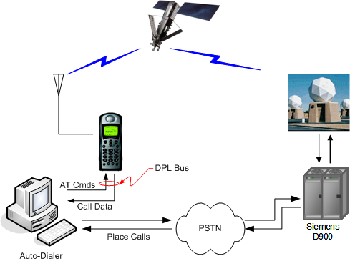
AES Terminated Voice Call Testing Configuration
Figure 3-1

AES Originated Voice Call Test Description
For AES originated (or mobile originated, MO) voice calls, the auto-dialer is set up to an Iridium telephone handset to place calls through the Iridium network to a telephone answering machine. The answering machine is configured to pick up the call on the first detected ring.

The Auto-dialer executes a script to place a call and to record call sequence timing from the computer and the telephone handset, via the digital peripheral link (DPL).

The Auto-dialer collects the call sequence timing from the point at which the call is initiated, answered by the answering machine and hung up, based on the test set up configuration, Figure 3-2, shown below:

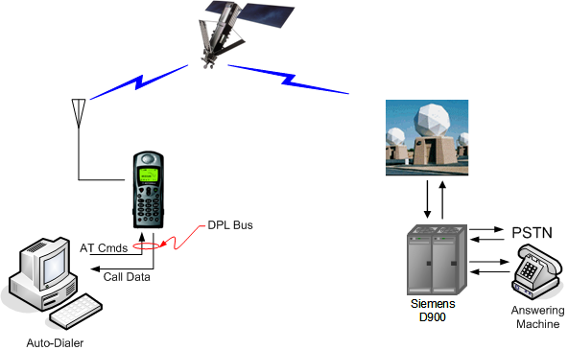
AES Originated Voice Call Testing Configuration
Figure 3-2

SBD Data Call Test Description
There are two scenarios for testing SBD data exchanges, AES to ground (MO), and ground to AES (MT). In both scenarios the auto-dialer is connected to an L band Transceiver (LBT) and to the SBD sub-system server via the gateway intranet. Both SBD transfers utilize the access channel for transfer of data.

The Auto-dialer executes a script to send the data and to record transfer sequence timing from end to end from the AES (LBT) to the SBD sub-system and from the SBD sub-system server to the AES (LBT).

The Auto-dialer collects the data transfer sequence timing from the point at which the call is initiated, answered and released, and checks the data to collect data transfer errors (data integrity), based on the test set up configuration, Figure 3-3, shown below:

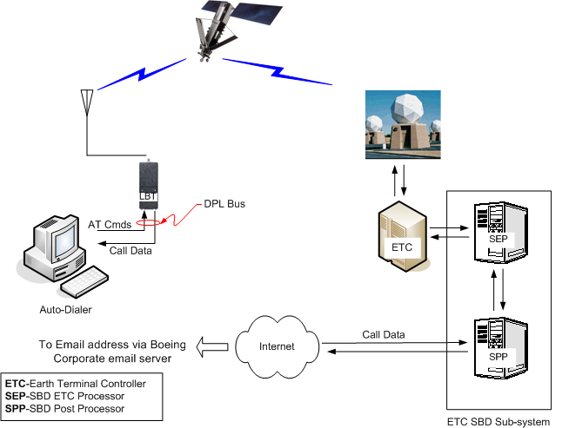
SBD Data Exchange Testing Configuration
Figure 3-3

RUDICS Data Call Test Description
There are two scenarios for testing RUDICS data calls, AES to ground (MO), and ground to AES (MT). In both scenarios the auto-dialer is connected to an L band Transceiver (LBT) and to the RUDICS server via the gateway intranet. During a AES to ground data call, the call is requested and set up in a normal calling setup sequence.

During a ground to AES data call, the system first issues a ring alert to the AES. Upon receiving the ring alert, the AES places a call to the Gateway to complete the connection. This results in the call establishment delay being slightly longer for a ground to AES data call than an AES to ground data call.

The Auto-dialer executes a script to place a call and to record call sequence timing from end to end from the AES (LBT) to the RUDICS server and from the RUDICS server to the AES (LBT).

The Auto-dialer collects the call sequence timing from the point at which the call is initiated, answered and hung up, and checks the data to collect data transfer errors (data integrity), based on the test set up configuration, Figure 3-4, shown:
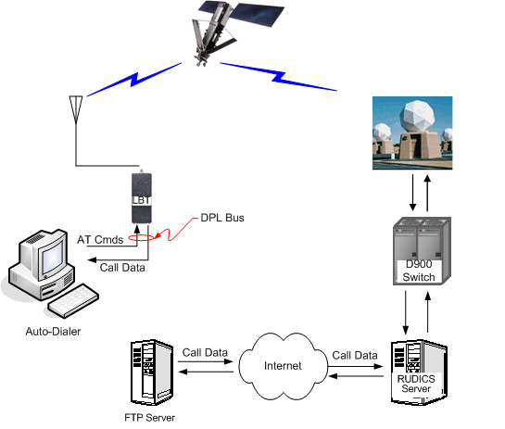
RUDICS Data Exchange Testing Configuration
Figure 3-4

Iridium supplied values.

